S.T.U. with Jesus
Super Training University with Jesus

Arts and Crafts Instructions

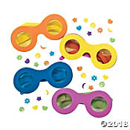
Depend on God (God cares) Crafts
Focus: Superheroes depend on God.
PRESCHOOL Craft: Super sunglasses
Goals
Superheroes will:
- Learn that God sees and cares for them.
- Think about ways God cares for them.
- Make a pair of sunglasses to remind them of God’s care. He sees and he watches over them.

SUPPLIES
- Kit can be purchased at umivbs.com

Leader preparation—What to Do before class
- Gather kits for each child.
- Make a sample necklace.
- Place supplies at each seat.

When the class arrives—Directions
- Provide each child with a sunglasses kit.
- Explain why we are making the craft—to remember that our super God sees and cares for us.
- Follow kit instructions.
- Encourage children to wear their sunglasses and affirm that our super God is always taking care of us.

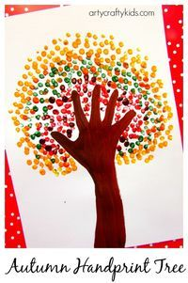
Preschool Craft: Hand Tree Art
Goals
Superheroes will:
- Learn that God sees and cares for them. He holds us all in his hand.
- Think about ways God cares for them.
- Make a tree to remind them of God’s care and that He holds us in his hand.
Supplies
White Paper
Finger paint or tempera paint
Small rubber bands
Cotton swabs (use rubber bands to bundle in groups of 3 and 4)
Brown construction paper (for cutting out trunks)
Leader preparation—What to Do before class
- Gather supplies.
- Make a sample handprint tree. Trace a kid’s hand and cut hand tree trunks for the class.
- Bundle the swabs
- Provide plates with small dabs of paint.
Leader tip: Collect old t-shirts to use as paint smocks for the children.

When the class arrives—Directions
- Provide each child with a sheet of white paper.
- Explain why we are making the craft—to remember that our super God sees and cares for us.
- Glue the trunk on the sheet of paper.
- To add leaves, Superheroes will use their fingers or the bundled swabs add leaves.

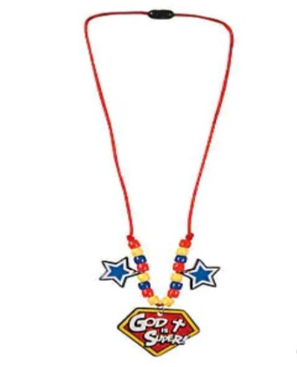
PRIMARY Craft: God is Super necklace
Goals
Superheroes will:
- Learn that God cares for them
- Think about ways God cares for them
- Make a necklace to remind them that our God is Super and that God care

Kit can be purchased at umivbs.com

Leader preparation—What to Do before class
- Make a sample necklace.
- Prepare necklace supplies for each Superhero.
- Provide kit instructions with a picture of the necklace.

Leader Tips
Use a paper plate for each child to keep the supplies corralled.

When the class arrives—Directions
- Provide each child with supplies.
- Explain we are making the necklace to remember that we are strong because our super God cares for us.
- Use the picture as a guide and string beads as pictured.
- Encourage children to wear their necklaces and affirm that we serve a super God!

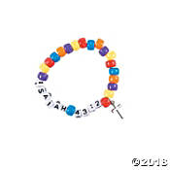
Primary Craft: Isaiah 43:2 Bracelet

Goals
Superheroes will:
- Learn God cares for them always.
- Think about ways God cares for them
- Make a bracelet to remind them that our God watches over us.

Kit can be purchased at umivbs.com

Leader preparation—What to Do before class
- Make a sample bracelet.
- Prepare supplies for each Superhero.
- Provide kit instructions with a picture of the bracelet.

Leader Tips
Use a paper plate for each child to keep the supplies corralled.

When the class arrives—Directions
- Provide each child with supplies.
- Explain why we are making the necklace to remember that our super God cares for us.
- Use the picture as a guide and string beads as pictured.
- Encourage children to wear their bracelets and affirm that we serve a super God!

JUNIOR Craft: Yarn wrapped pots
Goals
Superheroes will:
- Learn God cares for them
- Think about ways God cares for them
- Decorate a clay pot with string to remind them that like the string covering the pot, God’s care covers us and is unending. Just as He cares for plants, He watches over our lives.
Supplies
- Yarn
- Small clay pots
- Glue
- Foam brushes
Leader preparation—What to Do before class
- Gather supplies for each child.
- Make a sample yarn wrapped pot.
- Provide a covering for the table for easy cleanup (newspaper or a plastic tablecloth)
- Place supplies at each seat.
- You may choose to measure the amount of yarn to be used and pre-cut.
Leader Tips
Purchase multi-colored skeins of yarn.
Glue can be poured onto a small plate and applied with a foam brush.
With a sharpie pen, Superheroes can write God cares for me around the
the lip of the pot.

When the class arrives—Directions
- Provide each child with a pot, yarn, and glue.
- Explain why we are making the craft—to remember that just as we take care of the flowers we plant by watering it and giving it sunlight, God lovingly cares for us daily.
- Using the picture as a guide, apply glue to the bottom portion of the clay pot. Use the foam brush to smooth the glue over the entire surface.
- Add yarn by wrapping it around the pot starting at the bottom. Set pot aside to dry.
- Remind children God is always taking care of us.

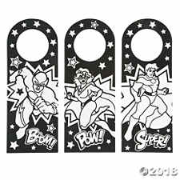
Junior Craft: Super Doorknob Hanger
Goals
Superheroes will:
- Learn God cares for them
- Think about ways God cares for them
- Decorate a doorknob hanger.

Kit can be purchased at umivbs.com
Leader preparation—What to Do before class
Gather supplies and make a sample doorknob hanger

When the class arrives—Directions
- Provide each child with a doorknob hanger and markers.
- Explain God lovingly cares for us daily. We are super because of his care.
- Remind children God is always taking care of us.

TEEN Craft: Yarn wrapped pots
Goals
Superheroes will:
- Learn God cares for them.
- Think about ways God cares for them.
- Decorate a clay pot with string to remind them that like the string covering the pot, God’s care covers us and is unending. Just as He cares for plants, He watches over our lives.
Supplies
- Yarn
- Small clay pots
- Glue
- Foam brushes
Leader preparation—What to Do before class
Check the supply list. Gather supplies for each child.
Make a sample yarn wrapped pot.
Provide a covering for the table for easy cleanup (newspaper or a plastic tablecloth)
Place supplies at each seat.
You may choose to measure the amount of yarn to be used and pre-cut.
Leader Tips
Purchase multi-colored skeins of yarn.
Glue can be poured onto a small plate and applied with a foam brush.
With a sharpie pen, Superheroes can write God cares for me around the
the lip of the pot.

When the class arrives—Directions
- Provide each child with a pot, yarn, and glue.
- Explain why we are making the craft—to remember that just as we take care of the flowers we plant by watering it and giving it sunlight, God lovingly cares for us daily.
- Using the picture as a guide, apply glue to the bottom portion of the clay pot.
- Add yarn by wrapping it around the pot starting at the bottom. Set pot aside to dry.
- Remind children God is always taking care of us.

Teen Craft: Woven Bookmark
Goals
Superheroes will:
- Learn we can depend on God.
- Think about ways God cares for them
- Use paper weaving to create a bookmark to
show that we are hemmed in with God’s care.
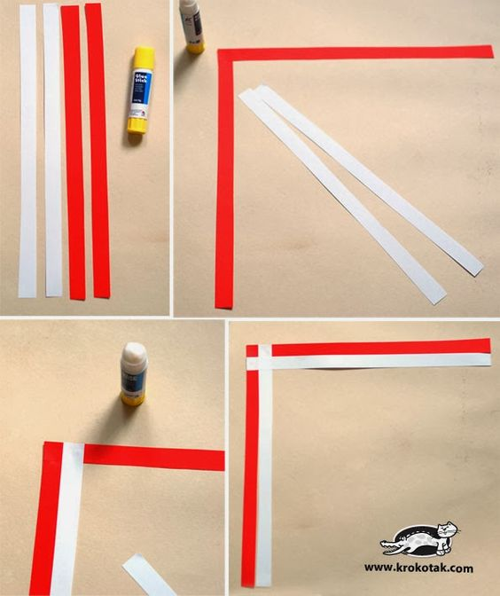
Supplies
- 2 different colors of paper cut into narrow ¼ inch strips.
- Glue sticks
Leader preparation—What to Do before class
- Gather supplies for each child: cut ¼ inch strips paper
- Make a sample woven bookmark.
- Place supplies at each seat—2 different color strips per Superhero.
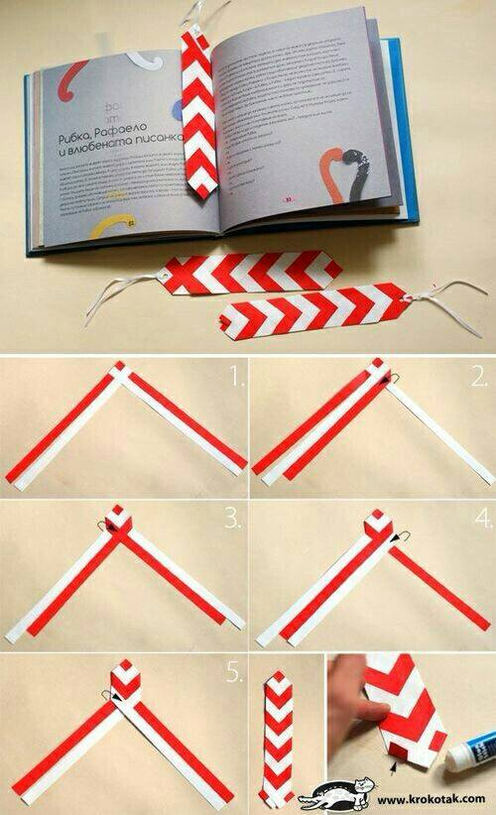
Leader Tips
Using a paper cutter will make the cutting easier and more accurate.

Directions
Start with 4 strips of paper--2 strips of 2 different colors.
Lay out the first 2 colors of strips as to form a 90-degree angle.
With the second color (in this case white), glue one strip next to the first red strip. The glue the second white strip so that it overlaps the first. (see picture)
With the strips in position, begin folding the outer r(ed)strip inward at an angle to align with the white strip. Then fold the white strips inward and continue folding until you get to the bottom. Glue the ends at the bottom to finish off.

Boldness
Focus: Superheroes are bold, 2 Corinthians 3:12

PRESCHOOL Craft: Superhero Cape
Goals
Superheroes will:
- Hear superheroes are bold.
- Think about ways they can be bold.
- Make a cape to remind them to be bold.

SUPPLIES
- Kit can be purchased at umivbs.com
- Markers for coloring or felt pieces for decoration.
Leader preparation—What to Do before class
Check the supply list. Provide a cape for each child.
Decorate a sample cape.
Place cape and markers at each seat.
Leader Tips
Optional—make your own cape with a t-shirt. See the instructions on the primary page.

When the class arrives—Directions
- Provide each child with a cape and markers.
- Explain why we are making the craft—to remember that we can be bold with our super God on our side.
- Have children color their capes.
- Encourage children to wear their capes and be bold.

PRIMARY: Superhero Cape (homemade)
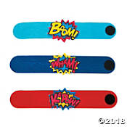
Primary Craft: Superhero cuffs
Goals
Superheroes will:
- Hear superheroes are bold
- Think about ways they can be bold
- Make a superhero cuff. We are bold because God gives us strength. He knows who we are and calls us by our name
Supplies
Leader preparation—What to Do before class
Kit: Superhero cuffs
(OTC: IN-13629209 $7.99 for 12)

Decorate a sample superhero cuff.
Place supplies at each seat

When the class arrives—Directions
Provide each child with a superhero cuff.
Follow kit instructions and decorate with foam stickers.

JUNIOR Craft: Superhero Cape (homemade)
Goals
Superheroes will:
- Learn superheroes are bold.
- Think about times they can be bold
- Make a superhero cape to remind to be bold.
Supplies
- T-shirt
- Scissors
- Adhesive backed Felt for decoration
- Foam stickers
- Sharpie markers
Leader preparation—What to Do before class
Provide a cape for each child.
Decorate a sample cape.
Place supplies at each seat.
Leader Tips
Use Velcro fasteners for safety, especially if the kids are going to be using the capes without adult supervision. Cut the front portion of the collar in half and attach Velcro fastener for ease of opening and closing.
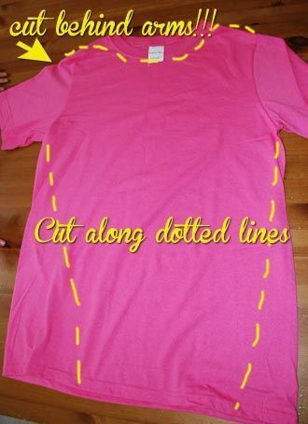
When the class arrives—Directions
- Layout T-shirt on the table.
- Cut along the side seams cutting off the sleeves. Follow the pattern to cut off the front of the shirt leaving the back and neck hole in place. (if using a velcro fastener the collar can be cut in half as pictured.)
- Let the kids decorate the back of their capes using sticky felt, foam stickers, acrylic paint or sharpie markers.
- Encourage children to wear their capes and be bold.

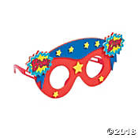
Primary Craft: Superhero glasses Goals
Superheroes will:
- Hear superheroes are bold.
- Think about ways they can be bold
- Make a pair of superhero glasses. We can bold when we can see that God is for us and on our side.

SUPPLIES
- Kit can be purchased at umivbs.com

Leader preparation—What to Do before class
Decorate a sample of superhero glasses.
Place supplies at each seat.

When the class arrives—Directions
Provide each child with supplies for superhero glasses.
Follow kit instructions and decorate with foam stickers.

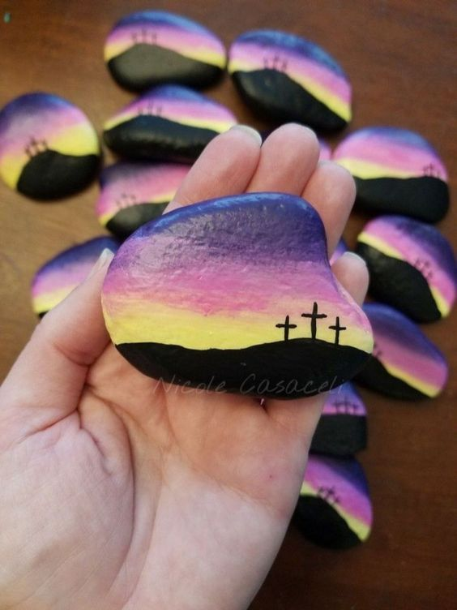
TEEN Craft: Painted rocks
Goals
Superheroes will
- Learn when we trust in God, we can be bold.
- Think about times when they need to be bold.
- Decorate a rock as a symbol that we can be bold because of what Jesus did for us on the cross. He is our rock and strength.
Supplies
- Rocks
- Sharpie markers (fine tip)
- Acrylic paints
- cotton swabs, foam brushes, toothpicks
Leader preparation—What to Do before class
1. Gather materials.
2. Make a sample prayer rock.
Let rock rest on a milk cap to keep it raised off the table. Then paint rocks. Start with lighter colors first---yellow and then pink. Add the purple and then the black. Use a sharpie marker to draw the details of the cross.
3. Protect work surface with newspaper/plastic tablecloth for easy cleanup.
4. Place materials- for the prayer rock at each seat.

Leader Tips
In the interest of time paint a base coat on the rocks the Superheroes will be decorating the day before class. This will allow them to go right to decorating during class. Provide some pictures of decorated rocks for inspiration.
When the class arrives—Directions
- Display the sample prayer rock.
- Explain why we are making the prayer rock—We can keep this special rock to remind us to always that God is our rock and strength. He makes us bold.
- Add color to the rock starting with yellow, then add pink and purple. Lastly, add the black. Finish off with the sharpie to add the detail of the cross.
- Encourage children to place their rocks somewhere where it will remind them to be bold.

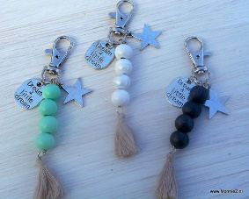
TEEN Craft:
Goals
Superheroes will
- Learn that when we trust in God, we are as bold as a lion.
- Think about times when they need to be bold.
- Create a tassel keychain as a symbol that God makes us bold
Supplies
- Keychain rings
- Beads
- Embroidery thread or thin yarn.
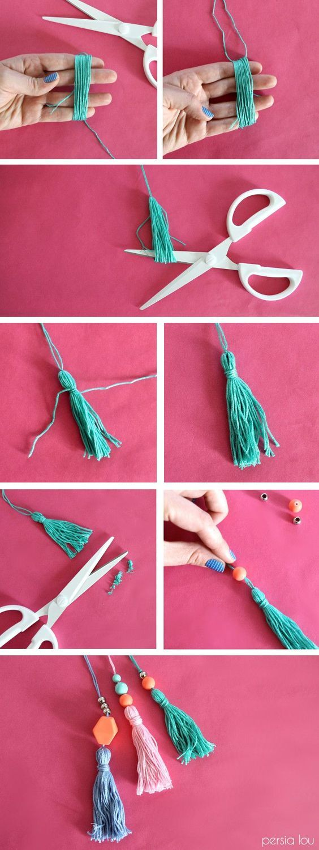
- Findings/charms
- Scissors
Leader preparation—What to Do before class
- Make a sample keychain.
- Cut out the 3 x 3-inch cards the Superheroes need to make tassels.
When Class arrives--Instructions
- Gather materials and make a sample keychain.
- Start with the tassel. Cut 2 piece of thread of yarn about 10 inches long. Lay aside.
- Then use a small card about 3 inches long and 3 inches wide. (you can also use your fingers as pictured. Wrap the thread or yarn around the card 12 times.
- Insert the piece of thread you laid aside under the bundle of the wrapped thread. Tie a knot twice and slide thread off the card and cut the bottom. (see picture)
- With another piece of thread/yarn, wrap around the top to the tassel to form a head. Tie off.
- Then add beads to the loose end of the thread.
- Tie the thread to the metal ring.
- Optional: Add a charm like a cross to the ring.

PRAYER
Focus: Superheroes pray for God’s help.

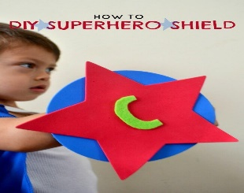
PRESCHOOL Craft: Superhero Shield
Goals
Superheroes will:
- Learn pray for God’s help
- Think about times they pray to God
- Make a shield to remind that when we pray to God, He
protects us like a shield.
Supplies
- Colorful cardstock cut into circle and star shapes.
- Super Jesus logo
- Stickers (optional)
- Markers for decorating
- Glue
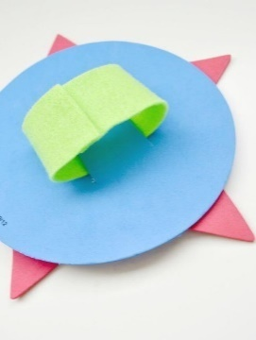
- Tape for attaching the strip in the back
Leader preparation—What to Do before class
- Cut out the shapes for the shield and a strip for the handle in the back.
- Make a sample shield.
- Place materials--a circle, star, strip, and glue-- at each seat.
Leader Tips
Superhero stickers, sticky gems, foam stickers, and markers can also be used in decorating the shield.

When the class arrives—Directions
- Display the sample shield.
- Explain why we are making the shield—to remember that our super God protects us like a shield when we pray to him.
- Cut 2 slits in the circle to insert the strip for the handle.
- Glue the star or another logo onto the front of the circle.
- Decorate the front of the shield with stickers, or children may add their own art designs.
- Encourage children to hold up their shields and declare “But you, O Lord are a shield for me.” (Psalm 3:3)
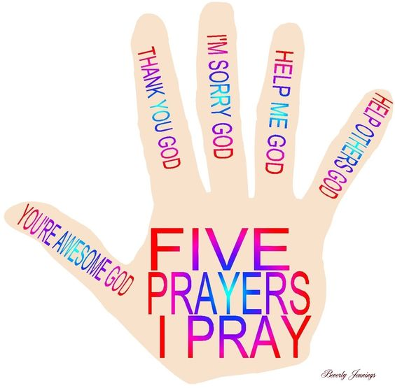
Preschool Craft: Praying Hand
Goals
Superheroes will:
- Learn to pray for God’s help
- Think about times they pray to God
- Make a praying had to remind us of things to we pray for.

Supplies
- Colorful cardstock
- Super Jesus logo
- Stickers (optional)
- Markers for decorating
- Glue

Leader preparation—What to Do before class
- Cut out the outline of a hand. Have enough for all Superheroes.
- Place materials--a hand cut-out at each seat., an extra piece of cardstock for mounting the hand, glue stick and other decorations at each seat.
- Additional supplies: gluesticks and other decorations like stickers, gems, etc.
- Printable finger prayers.
Leader Tips
Depending on how much time allowed, you can trace children’s hands in class. If time is limited, pre-cut hand images. Stickers and markers can also be used in decorating the hand.

When the class arrives—Directions
- Display the sample praying hand.
- Have children glue hand down onto cardstock. Cut around the handprint.
- Glue on the 5 prayers for each finger. (see printable)
- Explain what each finger reminds us to pray for.

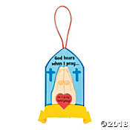
Primary Craft: God hears when I pray
Goals
Superheroes will:
- Learn to pray to God for help
- Think about what they can pray for
- Make a prayer banner to remind us God hears when we pray.

Supplies
- Prayer banner—God hears when we pray.
OTC: IN

Leader preparation—What to Do before class
Gather kits.
Make a sample prayer banner.
Place all materials- at each place.

When the class arrives—Directions
- Display the sample prayer banner.
- Explain why we are making the prayer banner—to remember that we can pray to God for help and he always hears.
- Have children decorate the banner according to kit instructions.

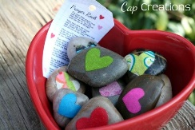
JUNIOR Craft: Prayer rocks
Goals
Superheroes will:
- Learn to pray to God for help in every situation.
- Think about things they can pray about.
- Decorate a prayer rock.
Supplies
- Rocks
- Spray paints in 2 -3 colors
- Sharpie markers
- Scrapbook paper
- scissors
- glue and foam brushes
Leader preparation—What to Do before class
- Gather materials.
- Layout rocks on a plastic tablecloth. Using the spray paints spray the rocks. Make 2 or three groups of different colors. Let dry.
2. Make a sample prayer rock.
3. Protect work surface with newspaper/plastic tablecloth for easy cleanup.
4. Place materials- for the prayer rock at each seat.

Leader Tips
Cut out small shapes of hearts, cross, etc. to have on hand before class. Superheroes can also cut their own shapes.

When the class arrives—Directions
- Display the sample prayer rock.
- Explain why we are making the prayer rock—We can keep this special rock to remind us to always pray to God for help.
- Have Superheroes glue on the small shape onto the rock. They can further use sharpie markers to add details or words. They may write PRAY on the rock or a short verse about prayer on the rock like “Pray always” (I Thess. 5:17).
- Use a foam brush to coat the entire top surface with glue. When dried, it will have a glossy finish.
- Encourage children to place their rocks somewhere where it will remind them to pray.

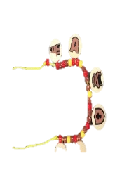
Alternate Junior craft: Armor Necklace
Goals
Superheroes will:
- Learn \prayer is a powerful spiritual weapon we can use against Satan.
- We pray for God for help in every situation.
- Think about things they can pray about.
- Make an armor necklace to remind us that with God on our side, we are powerful.

SUPPLIES
- Kit can be purchased at umivbs.com

Leader preparation—What to Do before class
1. Gather materials.
2. Make a sample armor necklace
3. Place kits at each seat.

When the class arrives—Directions
Display the sample armor of God necklace.
Explain why we are making the necklace—to remind us that prayer is one of the weapons we have as believers to defeat the devil.
Assemble necklace according to its instructions.

TEEN Craft: Prayer Jar
Goals
Superheroes will:
- Learn God they can pray to God in every situation
- Think about special things to pray for.
- Decorate a prayer jar and include reminders of different things to pray about.
Supplies
- Jar
- Sticky jewels
- Yarn
- Jumbo craft sticks
- Sharpie markers
- Scissors
- Glue
Leader preparation—What to Do before class
1. Gather materials.
2. Make a sample prayer jar.
3. Protect work surface with newspaper/plastic tablecloth for easy cleanup.
4. Place materials- for the prayer jar at each seat.
Leader Tips
Scraps of color scrapbook paper can also be used. Cut into hearts, cross, etc. and glued onto the jar. Coat with glue to seal.

When the class arrives—Directions
- Display the sample prayer jar.
- Explain why we are making the prayer jar—To remind us to pray for different requests.
- Have children decorate the jar. Use jewel stick-on, yarn, scrapbook paper, and so forth. They may write PRAY and attach with yarn. They could also include a short verse about prayer like “Pray always” (I Thess. 5:17).
- Write different things to pray about on jumbo craft sticks—
- Encourage children to place their rocks somewhere where it will remind them to pray.

Alternate Junior Craft: Washi clothespin

Goals
Superheroes will:
- Learn God they can pray to God in every situation
- Think about special things to pray for.
- Create clothespin magnets that can mount requests or prayer promises.

Supplies
- Clothespins
- Washi tape
- Magnetic strip
- Printable(s), cardstock
- cardstock and glue
Leader preparation—What to Do before class
1. Gather materials.
2. Make a sample clothespin magnet.
3. Place materials- washi tape, clothespins, printable(s) for decoration.

When the class arrives—Directions
- Decorate one side of clothespin with washi tape
- Add printable decoration.
- Attach a magnetic strip to the back of the clothespin.

JUSTICE
FOCUS: Superheroes defend justice for others
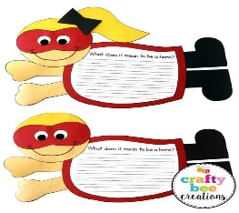
Preschool Craft: Superhero Banner
Goals
Superheroes will:
- Learn they can defend the justice for others
- Think about how they can stand up for a friend (in a bullying situation for example)
- Make a superhero banner to remind them God can help them defend justice for others.
Supplies
- Kid Superhero cut-out shapes (printable provided)
- Crayons, markers
- Glue sticks
Leader preparation—What to Do before class
1. Gather materials.
2. Make a flying superhero kid.
3. Place materials- for the project out for children.

When the class arrives—Directions
Display the sample flying superhero kid.
- Explain why we are making the superhero kid—To remind us that we can defend justice for others at home, school, or at play.
- Assemble the flying Superhero: Glue legs, arms onto the caped body. Add head
- Optional: Add stickers or preprinted word or scripture verse to the body.
- Remind children to always stand up for the right.

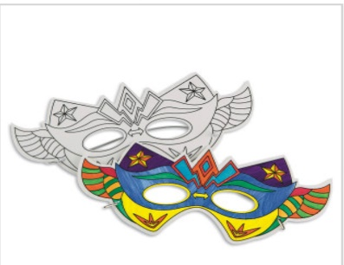
PRIMARY Craft: Superhero Masks
Goals
Superheroes will:
- Learn they can defend justice for others
- Think about how they can stand up for a friend (in a bullying situation for example)
- Make a mask to remind them they can stand up for others like superheroes.

SUPPLIES
- Kit can be purchased at umivbs.com

Leader preparation—What to Do before class
1. Gather materials.
2. Make a sample mask.
3. Place a mask at each seat.

Leader Tips
Protect work surface with newspaper/plastic tablecloth for easy cleanup.

When the class arrives—Directions
- Display the sample mask.
- Explain why we are making the superhero mask—To remind us to stand up for justice for others like a superhero.
- Have children decorate the mask with markers.
- Ask Superheroes to share situations when they could stand up for a friend.
- Encourage children to put on their mask and say: “I can do all things through Christ who gives me strength.” (Phil.4:13)

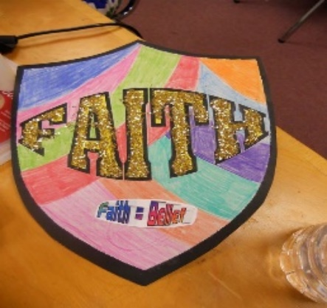
Primary Craft: Super Shield magnets
Goals
Superheroes will:
- Learn they can defend justice for others
- Think about how they can stand up for a friend (in a bullying situation for example)
- Make a shield to remind them they can stand up for others like superheroes.
Supplies
- Outline of Shield cutouts on White cardstock
- Colored cardstock for the background.
- Markers/ colored pencils
- magnets
- glitter or glitter glue
- scissors
- glue
Leader preparation—What to Do before class
1. Gather materials.
2. Make a sample shield.
3. Cut out shield out of white paper. Place one at each seat.
4. Distribute squares of colored cardstock a little bigger than the shields for mounting.

Leader Tips
Protect work surface with newspaper/plastic tablecloth for easy cleanup.

When the class arrives—Directions
- Display the sample shield.
- Explain that making the shield reminds us of our spiritual armor. We are encouraged to use the shield of faith to stop the fiery attacks of the devil. Our faith protects us.
- Decorate the shield with markers, colored pencils, glitter or glitter glue.
- When finished, mount a magnetic strip to the back.

JUNIOR Craft:
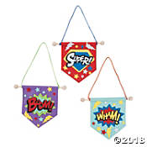
Super Mini Banners

SUPPLIES
- Kit can be purchased at umivbs.com

Leader preparation—What to Do before class
- Make a sample banner.
- Prepare supplies for each Superhero.
- Provide kit instructions with a picture of the bracelet.

Leader Tips
Use a paper plate for each child to keep the supplies corralled.

When the class arrives—Directions
- Provide each child with supplies.
- Explain that these banners remind us it is right to defend justice for others. God calls us to do justly and love mercy. (Micah 6:7)
- Use the picture as a guide to decorating banners.

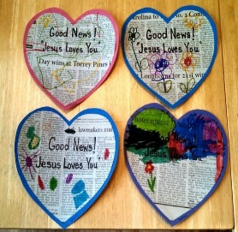
Junior Craft: Good News Heart
Goals
Superheroes will:
- Learn the good news of salvation in Jesus
- Think about the good news of God’s love for us and that Jesus died on the cross for us.
- Make a heart to remember God’s love.
Supplies
- Colored card stock
- Newspaper
- Markers
- Glue sticks

Leader preparation—What to Do before class
- Gather materials and make a sample heart.
- Cut hearts out of newspaper.
- Cut slightly larger hearts out of colored cardstock.

When the class arrives—Directions
- Display the sample heart.
- Explain we are making hearts to celebrate the good news that God loves us and all people. Jesus our original superhero who laid down his life to save us.
- Using a glue stick, glue the newspaper heart onto the colored heart.
- With markers draw and color across on the heart.
- Glue on the message, Good news: Jesus loves you!

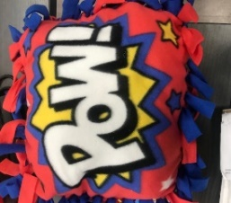
TEEN Craft: POW pillow

Goals
Superheroes will:
- Learn they can defend justice for others
- Think about how they can stand up for a friend (in a bullying situation for example)
- Make a pillow to remind them they have power from God to stand up for others.

SUPPLIES
- Kit can be purchased at umivbs.com

Leader preparation—What to Do before class
1. Gather materials.
2. Make a sample pillow.

When the class arrives—Directions
- Display the sample pillow.
- Explain we are making the pillow to remind us that it is right to defend justice for others. God calls us to do justly and love mercy. (Micah 6:7)
- Follow kit instructions laying out the fabric on a flat surface and tying knots to attach the front panel to the back. Stuff with fiberfill.
- Ask Superheroes to share situations when they could stand up for a friend.

Teen Craft:
SALVATION
Focus: Superheroes seek salvation through Jesus Christ
PRESCHOOL Craft:

Junior Craft: Good News Heart
Goals
Superheroes will:
- Learn the good news of salvation in Jesus
- Think about the good news of God’s love for us and that Jesus died on the cross for us.
- Make a heart to remember God’s love.
Supplies
- Colored card stock
- Newspaper
- Markers
- Glue sticks

Leader preparation—What to Do before class
- Gather materials and make a sample heart.
- Cut hearts out of newspaper.
- Cut slightly larger hearts out of colored cardstock.

When the class arrives—Directions
- Display the sample heart.
- Explain we are making hearts to celebrate the good news that God loves us and all people. Jesus our original superhero who laid down his life to save us.
- Using a glue stick, glue the newspaper heart onto the colored heart.
- With markers draw and color across on the heart.
- Glue on the message, Good news: Jesus loves you!

PRIMARY Craft:
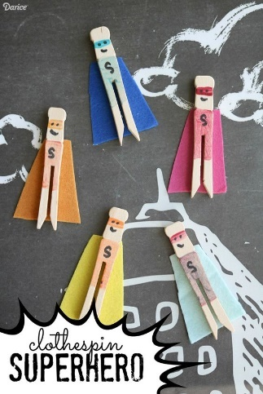
Clothespin superhero

Goals
Superheroes will:
- Learn they can find salvation in Jesus
- Think about how Jesus died for us on the cross
Make a superhero figure to remember Jesus is the original superhero who saves us from sin. When we accept his gift of salvation, we become members of his family.

Supplies
- Flat clothespins
- Felt
- Glue
- markers

Leader preparation—What to Do before class
- Gather materials and make a sample clothespin.
- Cut out capes from the felt. Start by cutting a small triangle. Cut off the top edge to make a cape. Cut it freehand or use template provided.

When the class arrives—Directions
- Display the sample superhero.
- Explain that Jesus is the original Superhero. He has defeated sin and death.
- Color the clothespin as pictured. Add details like a mask and face.
- Glue on the felt cape.

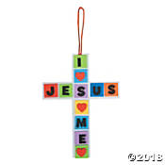
JUNIOR Craft: I Love Jesus Cross
Goals
Superheroes will:
- Learn they can find salvation in Jesus
- Think about how Jesus died for us on the cross
- Make a cross to remember the price Jesus paid for sin.

SUPPLIES
- Kit can be purchased at umivbs.com

Leader preparation—What to Do before class
1. Gather materials.
2. Make a sample cross.

When the class arrives—Directions
- Display the sample cross.
- Explain we are making the cross to remind us that Jesus died on the cross for us.
- Follow instructions from kit to assemble.
- Remind Superheroes that Jesus is the original superhero. He laid down his life to save us.

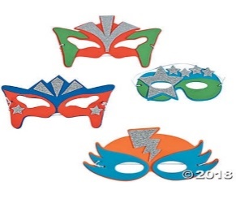
Junior Craft: Super Mask

Goals
Superheroes will:
- Learn can find salvation in Jesus, our original Superhero.
- Think about how Jesus died for us on the cross.
- Make a mask to remember the price Jesus paid for sin.

SUPPLIES
- Kit can be purchased at umivbs.com

Leader preparation—What to Do before class
Gather materials and make a sample mask.

When the class arrives—Directions
- Display sample mask.
- Follow instructions from kit to assemble.
- Remind Superheroes that Jesus is the original superhero. He laid down his life to save us.

TEEN Craft: Beaded Book thong bookmark
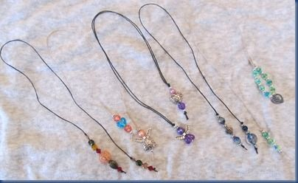
Goals
Superheroes will:
- Learn can find salvation in Jesus
- Know that Jesus is the original superhero who died for us on the cross.
- Make a beaded book thong bookmark with cross charm to remember the price Jesus paid for sin.
Supplies
- Small assorted beads
- Cross charm
- Waxed linen cord,

Leader preparation—What to Do before class
1. Gather materials.
2. Cut a section of cord, 15 inches, for each Superhero
3. Use a paper plate to easily manage materials.

When the class arrives—Directions
- Display the sample book thong.
- Explain why we are making the —To remind us that Jesus died on the cross for us.
- To begin, tie a knot at one end of the cord to keep beads from falling off. Add about 5 beads. Tie another knot to hold this group of beads together.
- Next work on the other end. Tie a knot about 2 to 3 inches from the end of the cord. Add the beads and charm. Tie a final knot to seal.
- Remind Superheroes that Jesus is the original superhero. He laid down his life to save us.

Teen Craft: Woven paper cross
Goals
Superheroes will:
- Learn can find salvation in Jesus
- Know that Jesus is the original superhero who died for us on the cross.
- Use paper weaving to create a cross to remember the price Jesus paid for sin.
Supplies
- Cross shape cut from a solid color
- Paper Strips
- Glue sticks/glue

Leader preparation—What to Do before class
1. Gather materials.
2. Cut cross patterns out of cardstock or solid colored paper
3. Fold cross vertically.
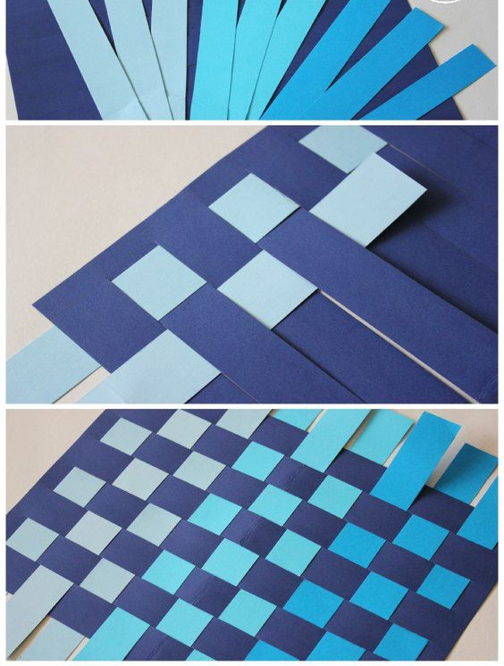
4. On folded edge, cut slits about ½ inches apart. Make sure the cuts do not go all the way through the edge of the paper.

When the class arrives—Directions
- Display sample woven cross.
- To weave: insert paper into the slits, over and under.
- Glue the ends down.

Worship
Focus: Superheroes worship God in spirit and truth

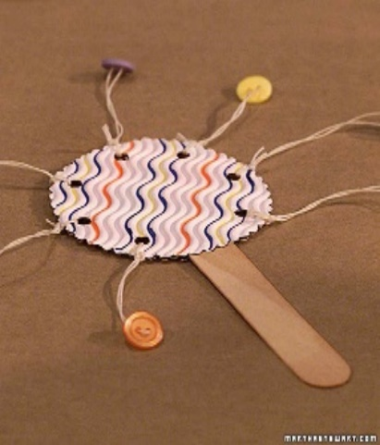
PRESCHOOL Craft: Super Spin drums
Goals
Superheroes will:
- Learn we worship God in spirit and truth.
- Think about the ways we worship. One way we worship is through music.
- Make a spin drum to use when singing praise to God.
Supplies
- 2 paper plates
- Hole punch, staple, glue
- String
- Jumbo craft stick
- Buttons or beads
Leader preparation—What to Do before class.
1. Gather materials.
2. Make a sample spin drum.
3. Place 2 circles, craft stick, string, and buttons on a plate for each Superhero.

Leader Tips
Add button to the string before class by running the string through the buttonhole. You may even tie a string to the circle base ahead of time and just let the children focus on decorating with stickers, markers.

When the class arrives—Directions
- Display the sample spin drum
- Explain that one way we worship God is through praise with instruments.
- Spread glue generously on the circle with glue. Sandwich the craft stick by placing place the second circle on top of first. For extra measure, staple craft sticks to circle.
- Use a hole punch to punch a hole around the outside of the circle but not too close to the edge.
- Decorate a circle with stickers and artwork.
- Tie the button on a string to circle and shake your spin drum.

Alternate Preschool Craft: Music shaker
Goals
Superheroes will:
- Learn we worship God in spirit and truth.
- Think about the ways we worship. One way we worship is through music.
- Make a shaker to use when singing praise to God.
Supplies
- Beads or rice for shaker
- Toilet roll tubes
- Colored paper
- Duct tape (plain or patterned)
Leader preparation—What to Do before class.
1. Gather materials and make a sample music shaker
2. Set out supplies for Superheroes.

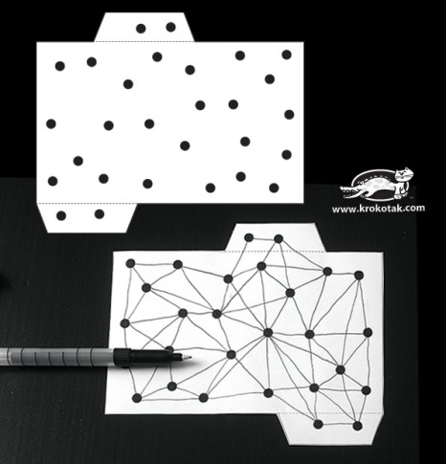
Leader Tips
If there are no toilet roll tubes, one can use cardstock to make this craft. See template. Superheroes may use white paper and decorate.
Patterned paper can also be used.

When the class arrives—Directions
- Start by covering the toilet roll with paper of choice-patterned paper or decorated white paper.
- Flattened one end of the roll and use duct tape to tape shut.
- Add beans or rice to the tube.
- Tape the other end close in opposite direction.
- Shake! Shake! shake!!

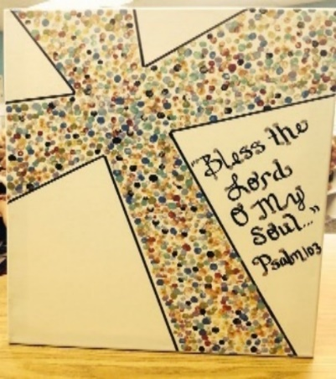
PRIMARY Craft: Worship banner
Goals
Superheroes will:
- Learn we worship God in spirit and truth.
- Think about ways we worship: Worship banners in church remind us of God’s attributes or acts.
- Make a worship banner.
Supplies
- Sheet of cardstock
- Assorted colors of acrylic paints.
- String for hanging banner
- Cotton swabs. Can be bundled into small groups of 3 or 5 with rubber bands,
- Paper plate
Leader preparation—What to Do before class.
1. Gather materials.
2. Make a sample worship banner.
3. Start with a cross outline on a cardstock.
4. On a paper plate add small dabs of different paint colors.

Leader Tips
Cotton swabs can be bundled in groups of 3 or 5 with rubber bands ahead of time.

When the class arrives—Directions
- Display the sample worship banner.
- Explain that one way we worship God is through art. Banners at church point us to God.
- Attach string/yarn to the back of the paper with tape.
- Write the verse on the banner.
- Then paint the cross by dabbing swabs in the paint and applying it to the cross.
- Let art dry.

Primary Craft: Magic Color Scratch Cross
Goals
Superheroes will:
- Learn we worship God in spirit and truth.
- Think about the ways we worship.
- Make a cross to remember that we worship Jesus who gave his life on the cross as payment for our sins.
Supplies
- Kit: Magic Color Scratch Kit
(OTC: IN-13784314 $ 8.99 for 24)
Leader preparation—What to Do before class.
Gather materials and make a sample.

When the class arrives—Directions
- Display the sample.
- Superhero uses a scratch tool to make their own design and uncover colors on the cross.

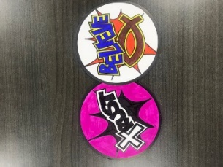
JUNIOR Craft: Word magnets
Goals
Superheroes will:
- Learn we worship God in spirit and truth.
- Think about the words we use when we worship.
- Make word magnets to remind us of the key aspects of our faith.

SUPPLIES
- Kit can be purchased at umivbs.com
Leader preparation—What to Do before class.
Gather materials and set out for Superheroes
When the class arrives—Directions
- Superheroes color and add magnets to the circular spheres.

Junior Craft: Stained glass window
Goals
Superheroes will:
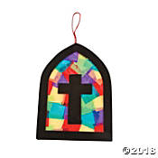
- Learn we worship God in spirit and truth.
- Think about the places we worship and the focus of our worship.
- Make a tissue paper stained glass window to point our hearts towards the cross.

SUPPLIES
- Kit can be purchased at umivbs.com

Leader preparation—What to Do before class.
Make a sample stained glass window.
Gather materials.

When the class arrives—Directions
- Superhero complete the window by following the kit instruction

TEEN Craft: String Art Heart
Goals
Superheroes will:
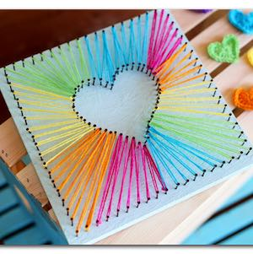
- Learn we worship God in spirit and truth.
- Think about the ways we worship. One way is to confess that our hearts belong to God.
- Make a string art heart
Supplies
- Cardstock cut into squares (6x 6 inches)
- Push pins
- Multi-colored yarn or embroidery thread.
- Small heart template
- Needle
Leader preparation—What to Do before class.
1. Gather materials.
2. Make a sample string art heart.
3. Start by cutting out 6x6 inch squares from foam core board.
4. Lightly trace a heart (use template) in center of the square. Then use a ruler to lightly trace lines around the border.

When the class arrives—Directions
- Display sample of a string art heart.
- Explain that one way we worship God is through acknowledging He lives in our hearts.
- Tape template onto a 6x 6 square of cardstock. With push pin, poke a hole in every marked dot. Remove template.
- Starting on an outer edge, insert a threaded needle at the bottom of the poked cardstock. Go from the outer dot to a corresponding inner dot on the heart. Push the needle through and return to the outer edge. Repeat moving from the outer edge to the heart go back and forth to make a stringed pattern around the entire heart.
- Tie off.

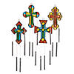
Teen Alternate Craft: Suncatcher Cross Windchimes
Superheroes will:
- Learn we worship God in spirit and truth.
- Think about the times we worship.
- Create a suncatcher cross windchime to remember we can worship God at all times.

SUPPLIES
- Kit can be purchased at umivbs.com

Leader preparation—What to Do before class.
1. Gather materials and make a sample.
2. Follow kit instructions to complete the project.

When the class arrives—Directions
- Pass out kits.
- Follow kit instructions to complete the project.

WITNESS
Focus: Superheroes share the good news

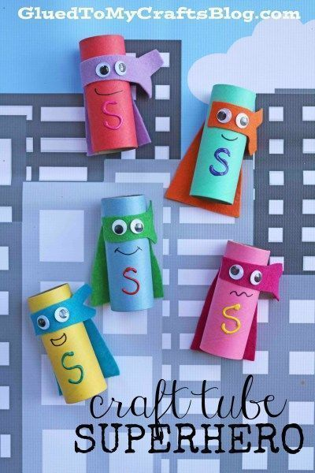
PRESCHOOL Craft: Tube Superhero
Goals
Superheroes will:
- Learn we can share the good news of Jesus Christ.
- Think about people we could share the good news with.
- Make a superhero
Supplies
- Colorful cardstock
- Googly eyes
- Colorful tubes
- Glue
- markers
Leader preparation—What to Do before class.
1. Gather materials.
2. Cut out capes and masks (see templates)
3. Place all materials on plates. Set out for Superheroes.

When the class arrives—Directions
- Display sample Superhero.
- Superheroes are happy to tell others about the greatest Superhero ever, Jesus!
- Use colored paper to cover a toilet roll tube.
- Glue on cape and masks. Add googly eyes and a smile.
- Add J for Jesus on the superhero chest.

Preschool Craft: Craft stick Popsicle Hero
Goals
Superheroes will:
- Learn we can share the good news of Jesus Christ.
- Think about people we could share the good news with.
- Make a superhero
Supplies
- Colorful cardstock
- Googly eyes
- Craft sticks
- Glue
- Markers
- Scissors
Leader preparation—What to Do before class.
1. Gather materials.
2. Cut out needed shapes: A triangle for the body, circle for the head, a handprint for a cape, and narrow strips for the arms and legs. (see templates)
3. Place all materials on plates. Set out for Superheroes.

When the class arrives—Directions
- Display sample superhero.
- Superheroes are happy to tell others about the greatest superhero ever, Jesus!
- Use craft sticks and paper cutouts to assemble a superhero.
- Glue the craft sticks onto the triangle. Add the cape, arms, legs, and head. on cape and masks. Add a small strip on the circle (head) for the mask. Glue on googly eyes. Draw on a smile.
- Add J for Jesus on the superhero chest.

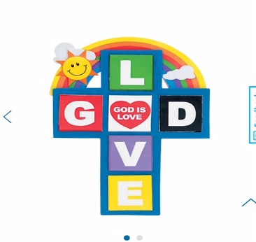
PRIMARY Craft: God is Love cross
Goals
Superheroes will:
- Learn we can share the good news of Jesus Christ.
- Think about people we could share the good news with.
- Make a God is love cross.
Supplies
- God is love Craft kit
(OTC: IN-48/6419 $5.99 for 12)
Leader preparation—What to Do before class.
1. Gather materials.
2. Put kits on paper plates and set out for Superheroes.
When the class arrives—Directions
- Display sample of a God is Love cross
- Mount the foam pieces on the cross according to the picture.
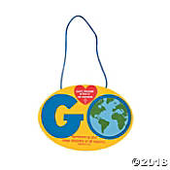
Primary Craft: Go and Tell Sign
Goals
Superheroes will:
- Learn we can share the good news of Jesus Christ.
- Think about people we could share the good news with.
- Make a go and tell sign to remember to tell others about Jesus.
Supplies

(OTC: IN-13596683 $8.99 for 12)
Leader preparation—What to Do before class.
1. Gather materials.
2. Put kits on paper plates and set out for Superheroes.
When the class arrives—Directions
- Display sample of go and tell sign.
- Assemble according to kit directions.
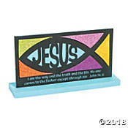
JUNIOR Craft: Jesus Mosaic
Goals
Superheroes will:
- Learn we can share the good news of Jesus Christ.
- Think about people to share the good news with.
- Make a plaque to witness to the presence of Jesus in all of life’s events.

SUPPLIES
- Kit can be purchased at umivbs.com

Leader preparation—What to Do before class.
1. Gather materials and make a sample.
2. Set out kits for Superheroes.
When the class arrives—Directions
- Display sample of Go and Tell sign.
- Assemble according to kit directions.

Junior Craft:
TEEN Craft: JESUS plaque
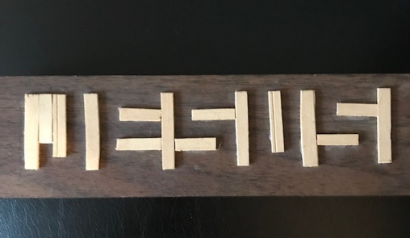
Goals
Superheroes will:
- Learn we can share the good news of Jesus Christ.
- Think about people we could share the good news with.
- Make a plaque to witness to the presence of Jesus in all of life’s events.

Supplies
- Jesus template
- Wooden coffee stirrers
- Cardstock for mounting the image.
- Glue
Leader Tip—Understanding this plaque: This plaque is a symbol of life. If you look at this plaque upside down, you will see nothing except an assortment of wood strips on a dark background. Even if you hold it up correctly, the message will not be immediately clear. The pieces of word represent the word JESUS but it must be viewed from a certain distance or perspective. Often it is difficult to see the LORD in life’s events, but faith teaches us that He is truly present despite what appears to be a meaningless jumble of unfortunate circumstances. JESUS is always in the background whether we see him or not. When we witness to others, we help others to see Jesus more clearly.
Leader preparation—What to Do before class.
1. Gather materials.
2. Cut coffee stirrers into the following lengths:
6—1 1/2 inch pieces
2—1 1/4 inch pieces
7— 1-inch pieces
When the class arrives—Directions
Display sample of plaque.
- Ask Superheroes what they see.
- Describe the significance of the plaque (see Leader tip)
- Mount the image on card stock.
- Glue coffee stirrers onto the image—see the key.

Teen craft: Jesus Mosaic
Goals
Superheroes will:
- Learn we can share the good news of Jesus Christ.
- Think about people to share the good news with.
- Make a plaque to witness to the presence of Jesus in all of life’s events.

Supplies
- Kit: Jesus Mosaic
(OTC: IN-13808826 $9.99 for 12)

Leader preparation—What to Do before class.
1. Gather materials and make a sample.
2. Set out kits for Superheroes.
When the class arrives—Directions
- Display sample of Go and Tell sign.
- Assemble according to kit directions.

PRAISE
Focus: Superheroes praise God

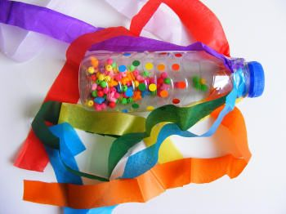
PRESCHOOL Craft: Super Shakers
Goals
Superheroes will:
- Learn we should praise God.
- Make a super shaker to praise to God.

Supplies
- Empty water bottle
- Rice, beans, or beads
- Circle stickers (in lots of different colors)
- Streamers cut from tissue paper (or ribbon) in all the colors of the rainbow
- Washi tape or colorful duct tape

Leader preparation—What to Do before class.
1. Collect empty water bottles. Wash and dry.
2. Gather other materials.
3. Lay out plates with stickers.

When the class arrives—Directions
- Display the sample super shaker.
- Pour in some beads into an empty water bottle. Fasten the bottle tightly (for younger children it could be taped in place).
- Decorate your bottle with the stickers and sticky tape. Let kids be creative.
- Cut one strip of tissue paper in each color. Arrange them around the neck of the bottle and tape in place.
- Then shake, shake, shake, in praise.

Preschool Craft: Maracas
Goals
Superheroes will:
- Learn we should praise God.
- Make maracas to praise to God.

Supplies
- Kit: Maracas
(OTC: IN-57/1020 $12.99 for 24)
- markers

Leader preparation—What to Do before class.
1. Gather materials and make a sample.
2. Set out supplies.

When the class arrives—Directions
- Display the sample maraca.
- Decorate maraca with markers. Let kids be creative.

- Then shake, shake, shake, in praise.

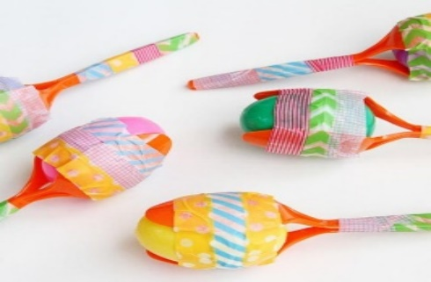
PRIMARY Craft: Marvelous Maracas
Goals
Superheroes will:
- Learn we should praise God.
- Make marvelous maracas to praise to God.

Supplies
- Plastic spoons
- Plastic eggs
- Rice, beans, or beads
- Washi tape
- Washi tape or colorful duct tape

Leader preparation—What to Do before class
1. Gather materials.
3. Lay out plates with supplies for each Superhero.

When the class arrives—Directions
- Display the marvelous maracas.
- Pour in some beads into plastic eggs.
- Put two spoons together, with the heads of the spoons facing.
- With washi tape begin wrapping it tightly around the handles of the spoons. Alternate with different washi tape patterns to make your maraca handles more colorful.
- Open the heads of the spoons slightly and set an egg inside the heads of the spoon,
- Wrap your egg with washi tape, beginning by going over the seam of the egg. Going around with the tape 2-3 times around the seam will make it more secure. Add more washi tape to cover the rest of the egg.
- Then shake, shake, shake, in praise.

Primary and Junior Craft: Balloon Drum
Goals
Superheroes will:
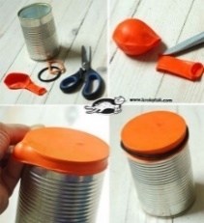
- Learn we should praise God.
- Make balloon drums to praise to God.

Supplies
- Balloons
- Empty can washed and dried
- Scissors
- Rubber bands
- Washi tape or colorful duct tape
- Other decorations: stickers

Leader preparation—What to Do before class
1. Gather materials and make a sample.
2. Lay out plates with supplies for each Superhero.

When the class arrives—Directions
- Cut the neck off a balloon.
- Stretch to cover the can.
- Use a rubber band to secure the balloon to the can.
- Decorate with tape.
- Use an unsharpened pencil as a drumstick

JUNIOR craft: Posters
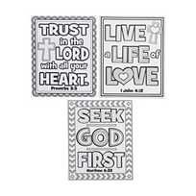
Superheroes will:
- Learn we should praise God.
- Make posters to praise to God.

SUPPLIES
- Kit can be purchased at umivbs.com

Leader preparation—What to Do before class
1. Gather materials and make a sample.
2. Lay out plates with supplies for each Superhero.

When the class arrives—Directions
Be creative and decorate the posters as desired. Use markers, colored pencils, glitter glue, glitter etc.
Make the posters as a token of praise to God.

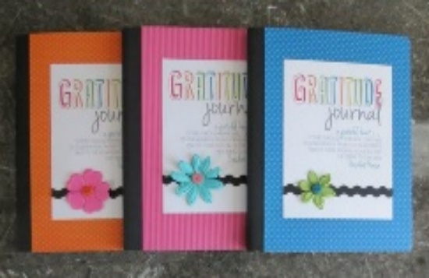
TEEN Craft:
Goals
Superheroes will:
- Learn we should praise God.
- Think of some reasons to praise God.
- Make a gratitude journal. Keep a record of daily blessings you are grateful for. Giving thanks to the Lord is good.

Supplies
- Composition Books
- Gratitude Journal printable
- Decorative Strip of paper
- Decorative stickers/Superhero stickers
- Glue/adhesive
Leader preparation—What to Do before class.
1. Gather materials.
2. Lay out plates with supplies for each Superhero.

When the class arrives—Directions
- Display a sample journal.
- Glue the printable title sheet onto the front of the composition book.
- Creatively decorate the cover. Use stickers, washi tape, paper strips.

Teen Craft:

PROTECTION
Focus: Superheroes protect/defend others

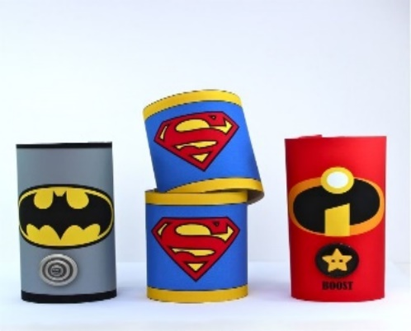
PRESCHOOL Craft: Superhero cuffs
Goals
Superheroes will:
- Learn Superheroes protect and defend others.
- Think of how you could protect another.
- Make superhero cuffs to remind you to protect others.

Supplies
- Toilet roll or paper towel rolls
- Colored paper
- Washi tape
- glue
- odd buttons to glue on for additional gadgets/accessories
- printable with Superhero logos
Leader preparation—What to Do before class.
1. Gather materials.
2. Lay out plates with supplies for each Superhero.
3. Cut the rolls down the middle lengthwise to create a cuff shape. Cut the rolls down to shorten for the younger children.

When the class arrives—Directions
- Provide each Superhero with 2 matching cuffs to decorate.
- Use glue to cover the tubes with colorful paper. Fold the ends over the cut edges and glue in place.
- Add washi tape around the edges.
- Decorate with Superhero logo/stickers and any other materials like strips of paper and markers.

Preschool Craft: Superhero wand
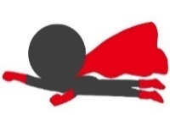
Goals
Superheroes will:
- Learn that superheroes protect and defend others.
- Think of how you could protect another.
- Make superhero wand to remind you to protect others.

Supplies
- Colored paper
- Scissors
- Glue
- Wooden dowel or wooden skewer
Leader preparation—What to Do before class.
1. Gather materials.
2. Lay out plates with supplies for each Superhero.
3. Cut the body parts. (use template)

When the class arrives—Directions
- Assemble Superhero.
- Tape onto dowel or skewer.

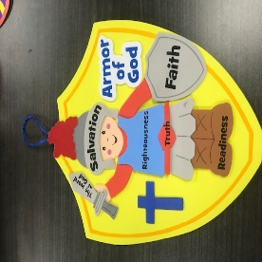
PRIMARY Craft: Armor of God shield
Goals
Superheroes will:
- Learn Superheroes protect and defend others.
- Think of ways you could protect a friend.
- Make an armor of God shield to remember that we that we have the armor of God as our shield. With God as our strength, we can help others.

SUPPLIES
- Kit can be purchased at umivbs.com

Leader preparation—What to Do before class.
1. Gather materials and make a sample.
2. Set out kits for Superheroes.

When the class arrives—Directions
- Display the sample shield.
- Assemble as pictured in the kit.

Primary Craft: Superhero cuffs
Goals
Superheroes will:
- Learn that superheroes protect and defend others.
- Think of how you could protect another.
- Make superhero cuffs to remind you to protect others.

Supplies
- Toilet roll or paper towel rolls
- Colored paper
- Washi tape
- glue
- odd buttons to glue on for additional gadgets/accessories
- printable with Superhero logos
Leader preparation—What to Do before class.
1. Gather materials.
2. Lay out plates with supplies for each Superhero.
3. Cut the rolls down the middle lengthwise to create a cuff shape.

When the class arrives—Directions
- Provide each Superhero with 2 matching cuffs to decorate.
- Use glue to cover the tubes with colorful paper. Fold the ends over the cut edges and glue in place.
- Add washi tape around the edges.
- Decorate with Superhero logo/stickers and any other materials like strips of paper and markers.

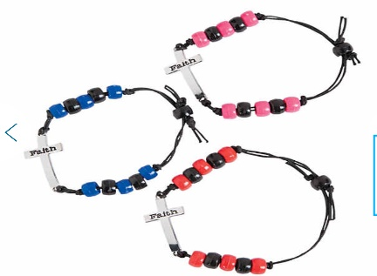
JUNIOR Craft: Friendship bracelets
Goals
Superheroes will:
- Learn Superheroes protect and defend others.
- Think of occasions when they might have to protect someone from danger
- Make a friendship bracelet to remind you to be a friend indeed—one who protects and defends.

SUPPLIES
- Kit can be purchased at umivbs.com

Leader Tip—Swap out the beads in the kit with wooden ones for a more polished bracelet.
Leader preparation—What to Do before class.
1. Gather other materials.
2. Lay out plates with supplies for each Superhero.

When the class arrives—Directions
- Display the sample friendship bracelet.
- Think about times when you had to protect and defend another.
- Follow kit guidelines for completing bracelet.

Junior Craft: Scratch Bookmarks

Goals
Superheroes will:
- Learn Superheroes protect and defend others.
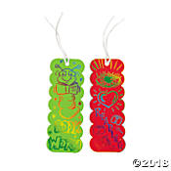
- Think of occasions when they might have to protect someone from danger
- Make a bookmark to remind you to be a friend indeed—one who protects and defends.

Supplies
- Kit: scratch Bookmarks
(OTC: IN-48/7981 $6.99 for 24)
Leader preparation—What to Do before class.
1. Gather other materials.
2. Set out bookmarks for Superheroes.

When the class arrives—Directions
- Display the sample bookmark.
- Think about times when you had to protect and defend another.
- Decorate the bookmark. Use a scratch tool to create a unique creation.

Teen Craft: Faith Stone bracelet
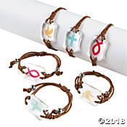
Goals
Superheroes will:
- Learn Superheroes protect and defend others.
- Think of occasions when they might have to protect someone from danger
- Make a friendship bracelet to remind you to be a friend indeed—one who protects and defends.

Supplies
- Kit: Faith Stone Bracelet kit
(OTC: IN-13626135 $8.99 for 12)

Leader preparation—What to Do before class.
1. Gather materials and make a sample bracelet.
2. Layout supplies for each Superhero.

When the class arrives—Directions
- Display the sample friendship bracelet.
- Think about times when you had to protect and defend another.
- Follow kit guidelines for completing bracelet.

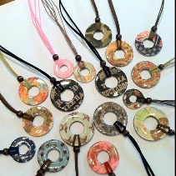
Teen Craft: Washer Necklace
Goals
Superheroes will:
- Learn Superheroes protect and defend others.
- Think of occasions when they might have to protect someone from danger
- Make a washer necklace to remind you to be a friend in deed—one who protects and defends.

Supplies
Washer (washers with a small hole in the center work best, they are often called fender washers)
Patterned paper
Pencil
Craft knife (optional)
Scissors
Tacky glue & brush
Emery board
Tacky glue
1 Ribbon or cord
Leader preparation—What to Do before class.
1. Gather materials and make a sample necklace.
2. Layout supplies for each Superhero.

When the class arrives—Directions
- Trace the washer on patterned paper. Trace both outside circle and the inside circle.
- Cut out the traced circle.
- Use a hole punch to punch out the inner circle.
- Spread glue on the rough side of the washer.
- Position the cut circle on top of the glue.
- To add ribbon, fold the ribbon in half and feed the loop through the center of the washer.
- Thread the ribbon ends through the loop and pulls to secure.
- Check the length of the necklace before tying off (it needs to be able to slip over your head easily). Tie a knot at the correct length and trim the ends.

FAITHFULNESS

PRESCHOOL Craft: Superframe

Goals
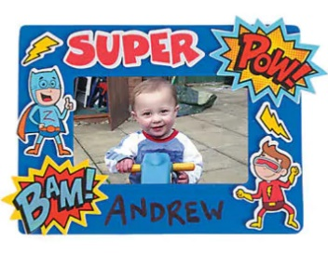
Superheroes will:
- Learn that we God is faithful and has a plan for us all.
- Thank God for making us special.
- Make a Superframe to celebrate the special person God has made.

SUPPLIES
- Kit can be purchased at umivbs.com
Leader Tip—Take pictures of your Superheroes the day before this craft and make copies to insert in the frame.
Leader preparation—What to Do before class.
1. Gather other materials.
2. Lay out plates with supplies for each Superhero.

When the class arrives—Directions
- Display the sample frame.
- Decorate the frame with the stickers provided.

Preschool Craft: Faith Bookmark

Goals
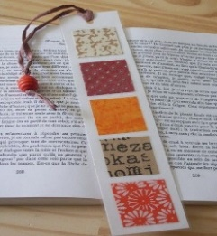
Superheroes will:
- Learn God is faithful. His faithfulness never ends.
- We can have faith in God.

Supplies
- Cardstock
- Patterned paper squares
- Ribbon or yarn
- Glue, glue sticks
Leader preparation—What to Do before class.
  - Gather other materials.
  - Cut cardstock into bookmarks, 2inche by 6 inches
  - Lay out plates with supplies –1 bookmark and 5 squares.

When the class arrives—Directions
- Display the sample bookmark
- Glue on the 5 squares.
- Punch a hole in the top of the bookmark. Add the ribbon or yarn.
- Optional: Write the letters F A I T H on the squares.

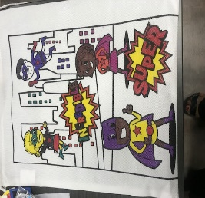
Primary Craft: Super Backpack
Goals
Superheroes will:
- Learn God is faithful. His faithfulness never ends.
- We can have faith in God because he’s got us in his hands.
- Make a super backpack.

SUPPLIES
- Kit can be purchased at umivbs.com

Leader preparation—What to Do before class.
- Set backpacks out.

When the class arrives—Directions
- Color the backpack.

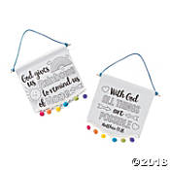
Primary Craft: Color your own faith banner
Goals
Superheroes will:
- Learn that God is faithful. His faithfulness never ends.
- We can have faith in God because He has us in his hands.
- Make a faith banner.

SUPPLIES
- Kit can be purchased at umivbs.com

Leader preparation—What to Do before class.
Set out supplies.

When the class arrives—Directions
- Color the banners

JUNIOR Craft: Pencil Holder
Goals
Superheroes will:
- Learn that God has a plan for us.
- Think about God’s faithfulness in our lives.
- Decorate an empty can to remind them God is faithfully making something beautiful and useful out of our lives as we trust in Him. He can use the ordinary, even what some people consider insignificant or unimportant, and transform it into something extraordinary.

Supplies
- The empty vegetable can or juice can
- Paper scraps
- Washi tape
- Other supplies on hand like gems, stickers.
Leader Tip— If you are not able to collect enough cans ahead of time, plastic cups empty frozen juice containers or jars, could be used instead.
Leader preparation—What to Do before class.
1. Gather other materials.
2. Lay out plates with supplies for each Superhero.

When the class arrives—Directions
- Display the sample pencil holder.
- Begin by wrapping the washi tape onto the container. Be creative:
Strips of tape can be wrapped vertically, horizontally or vertically.
- For added inspiration, a verse on a strip of paper can be added around the rim or base of the container.

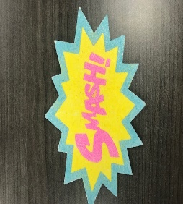
Junior Craft: Super Sand Art

Goals
Superheroes will:
- Learn that God is faithful. His faithfulness never ends.
- We can have faith in God because He has us in all-powerful his hands.
- Make super smash sand art.

SUPPLIES
- Kit can be purchased at umivbs.com

Leader preparation—What to Do before class.
Set out supplies. Make a sample.

When the class arrives—Directions
Follow kit instructions to complete sand art project.

TEEN Craft: Clothespin Trivet
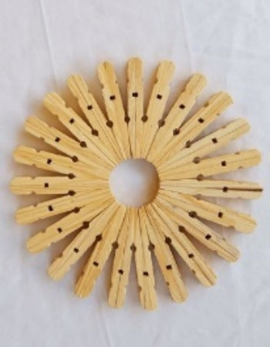
Goals
Superheroes will:
- Learn God has a plan for us.
- Think about God’s faithfulness in our lives.
- Decorate an empty can to remind them God is faithfully making something beautiful and useful out of our lives as we trust in Him. He can use the ordinary, even what some people consider insignificant or unimportant, and transform it into something extraordinary.

Supplies
- Clothespins, deconstructed
- Glue
Leader Tip— The Tacky Glue will work better for this project. Also, get extra help in taking the clothespins apart by removing the metal hinge. Have a picture of
Leader preparation—What to Do before class.
1. Gather other materials.
2. Lay out plates with supplies for each Superhero—23 clothespins per Superhero.

When the class arrives—Directions
- Display the sample trivet.
- Arrange the straight sides of the clothespin back to back in a circular pattern first.
- Glue the pieces together.

Teen Craft: Painted Wooden Cross
Goals
Superheroes will:
- Learn God has a plan for us.
- Think about God’s faithfulness in our lives.
- Paint to remind them God is faithfully making something beautiful and useful out of our lives as we trust in Him. His plans are always for our good.

Supplies
- Kit: wooden crosses
(OTC: IN-48/3760
- Acrylic paints, foam brushes

Leader Tip— Protect the surface with newspaper or a plastic tablecloth since Superheroes are working with paint.
Leader preparation—What to Do before class.
1. Gather other materials.
2. Lay out plates for paint.

When the class arrives—Directions
Superhero paint the wooden cross in their desired color.

Templates:
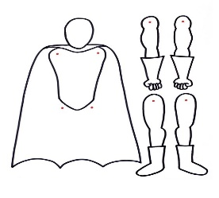

FAITH

